# William Colon

# 1-2

# CS 499 Module One Assignment Template

Complete this template by replacing the bracketed text with the relevant information.

1. **Self-Introduction:** Address all of the following questions to introduce yourself.
   1. How long have you been in the Computer Science program?

**For about 4 years**

* 1. What have you learned while in the program? List three of the most important concepts or skills you have learned.

**I learn a lot of commands in Linux, lerner about cyber security and how hackers approach for an attack and network protocls**

* 1. Discuss the specific skills you aim to demonstrate through your enhancements to reach each of the course outcomes.

**Im a 4 kid father with a job who have to maintain a house hold fixing tha home cars mowing the yard among many things to reach the outcomes many tears perseverance and hours of tiredness.**

* 1. How do the specific skills you will demonstrate align with your career plans related to your degree?

**Perseverance is really important when working with computers because most times you don’t get what you are trying to accomplish and you need to continue trying and ginding defferent ways to do it to complete the task**

* 1. How does this contribute to the specialization you are targeting for your career?

**Having this knoladge helps with networking and computer technician where im working as in right now**

1. **ePortfolio Set Up:**
   1. Submit a **screen capture** of your ePortfolio GitHub Pages home page that clearly shows your URL.
   2. 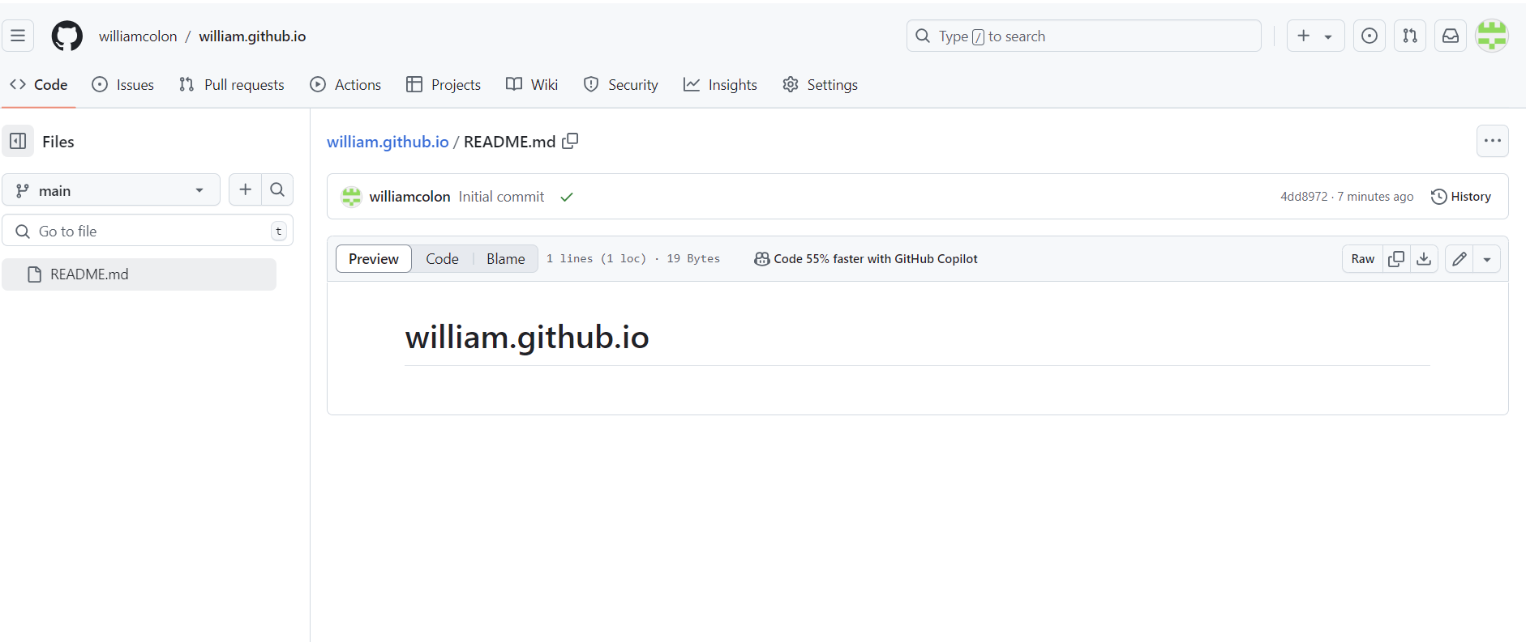
      1. You already have a repository in GitHub where you uploaded projects in previous courses. Your ePortfolio will reside in GitHub but can link to work at other sites, such as Bitbucket.
   3. Use the GitHub Pages link in the Resource section for directions on:
      1. How to create your GitHub website and publish code to GitHub Pages
      2. Issues, such as adding links to other sites
   4. Paste a screenshot of your GitHub Pages home page with your URL clearly showing in the space below. 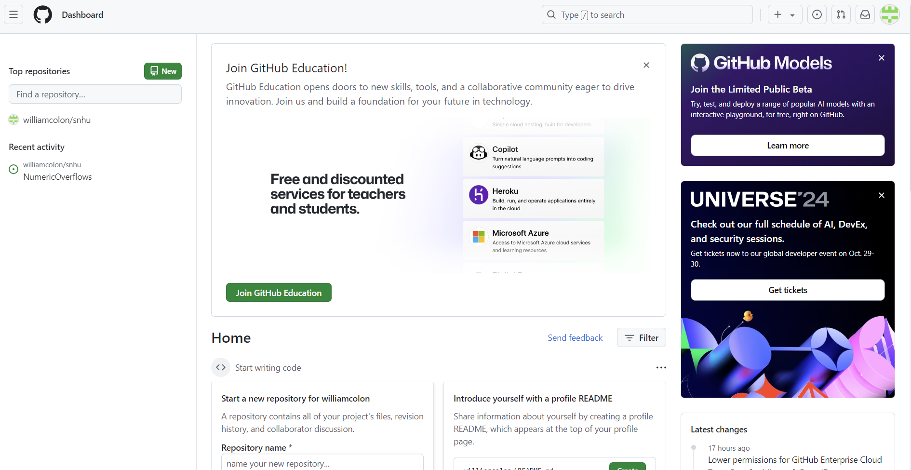
2. **Enhancement Plan:** 
   1. **Category One:** Software Engineering and Design
      1. **Select an** **artifact** that is **aligned with** **the** software engineering and design **category** and explain its origin. Submit a file containing the code for the artifact you choose with your enhancement plan.

**The one I selected come from the class Software Testing, Automation where Static testing, with this software testing method, you can Test reviews early in the life cycle of a program to checks for defects or catch bugs you can look over the code without the need of running the code.**

Note: Your artifact may be work from the following courses:

* IT 145: Foundation in Application Development
* CS 250: Software Development Lifecycle
* CS 260: Data Structures and Algorithms
* IT 315: Object Oriented Analysis and Design
* CS 320: Software Testing, Automation, and Quality Assurance
* CS 330: Computational Graphics and Visualization
* CS 340: Advanced Programming Concepts
* CS 350: Emerging Systems Architectures and Technologies
* CS 360: Mobile Architecture and Programming
* IT 365: Operating Environments
* IT 380: Cybersecurity and Information Assurance
* CS 405: Secure Coding
* CS 410: Reverse Software engineering
* IT 340: Network and Telecommunication Management
* IT 380: Cybersecurity and Information Assurance
  + 1. **Describe** a practical, well-illustrated **plan** for enhancement in alignment with the category, including a pseudocode or flowchart that illustrates the planned enhancement.

**My code is in Java an appointment system that have the information withing the code I will modified to C++ and to ask for the information and be able to enter manually all the info.**

**Knowing my code was technically correct using the basic coding language. This was helpful because I knew what worked and how to follow the code. It helped me keep track of what I added or removed in the code respecting the requirements. From my Contact class here is an example "assertEquals("Billy", testContact.getFirstName());". By following this procedure, you can determine the name that the code requires. By doing so, it was possible to give the test class its name in the example.**

For this category of enhancement, consider improving a piece of software, transferring a project into a different language, reverse engineering a piece of software for a different operating system, or expanding a project’s complexity. These are just recommendations. Consider being creative and proposing an alternative enhancement to your instructor.

Think about what additions to include to complete the enhancement criteria in this category. Since one example option is to port to a new language, that is the kind of scale that is expected. This does not mean you need to port to a new language but instead have an equivalent scale of enhancement. Underlying expectations of any enhancement include fixing errors, debugging, and cleaning up comments, but these are not enhancements themselves.

* + 1. Explain how the planned enhancement will **demonstrate** specific **skills** and align with course outcomes.
       1. Identify and describe the specific skills you will demonstrate that align with the course outcome.

**Here I will be learnin for the first time how to code in C++**

* + - 1. Select one or more of the course outcomes below that your enhancement will align with.

**Im looking to have this code more interactive and asking for the information instead on having the info embedded in the code**

Course Outcomes:

1. Employ strategies for building collaborative environments that enable diverse audiences to support organizational decision-making in the field of computer science.
2. Design, develop, and deliver professional-quality oral, written, and visual communications that are coherent, technically sound, and appropriately adapted to specific audiences and contexts.
3. Design and evaluate computing solutions that solve a given problem using algorithmic principles and computer science practices and standards appropriate to its solution while managing the trade-offs involved in design choices.
4. Demonstrate an ability to use well-founded and innovative techniques, skills, and tools in computing practices for the purpose of implementing computer solutions that deliver value and accomplish industry-specific goals.
5. Develop a security mindset that anticipates adversarial exploits in software architecture and designs to expose potential vulnerabilities, mitigate design flaws, and ensure privacy and enhanced security of data and resources.
   1. **Category Two:** Algorithms and Data Structures
6. **Select an artifact** that is **aligned with the** algorithms and data structures **category** and explain its origin. Submit a file containing the code for the artifact you choose with your enhancement plan. You may choose work from the courses listed under Category One.

**I will enhance my selected artifact with algorithm to make it more interactive**

1. **Describe** a practical, well-illustrated **plan** for enhancement in alignment with the category, including a pseudocode or flowchart that illustrates the planned enhancement.

**Not sure yet how I will tackle the algorithm part but I will look into the C++ guide and some search to accomplish this.**

For this category of enhancement, consider improving the efficiency of a project or expanding the complexity of the use of data structures and algorithms for your artifact. These are just recommendations. Consider being creative and proposing an alternative enhancement to your instructor. Note: You only need to choose one type of enhancement per category.

Think about what additions to include to complete the enhancement criteria in this category. Since one example option is to port to a new language, that is the kind of scale that is expected. Perhaps you might increase the efficiency and time complexity of an algorithm in an application and detail the logic of the increased time complexity. Remember, you do not need to port to a new language but instead have an equivalent scale of enhancement. Underlying expectations of any enhancement include fixing errors, debugging, and cleaning up comments, but these are not enhancements themselves.

1. Explain how the planned enhancement will **demonstrate** specific **skills** and align with course outcomes.
   1. Identify and describe the specific skills you will demonstrate to align with the course outcome.

**[Insert your answer here.]**

* 1. Select one or more of the course outcomes listed under Category One that your enhancement will align with.

**I will do my best to make this work sice is written in Java and Im changing the code to run in C++**

* 1. **Category Three: Databases**
     1. **Select an artifact** that is **aligned with the** databases **category** and explain its origin. Submit a file containing the code for the artifact you choose with your enhancement plan. You may choose work from the courses listed under Category One.

**[Insert your answer here.]**

* + 1. **Describe** a practical, well-illustrated **plan** for enhancement in alignment with the category, including a pseudocode or flowchart that illustrates the planned enhancement.

**[Insert your answer here.]**

For this category of enhancement, consider adding more advanced concepts of MySQL, incorporating data mining, creating a MongoDB interface with HTML/JavaScript, or building a full stack with a different programming language for your artifact. These are just recommendations; consider being creative and proposing an alternative enhancement to your instructor. Note: You only need to choose one type of enhancement per category.

Think about what additions to include to complete the enhancement criteria in this category. Since one example option is to port to a new language, that is the kind of scale that is expected. Perhaps you might increase the efficiency and time complexity of an algorithm in an application and detail the logic of the increased time complexity. Remember, you do not need to port to a new language but instead have an equivalent scale of enhancement. Underlying expectations of any enhancement include fixing errors, debugging, and cleaning up comments, but these are not enhancements themselves.

* + 1. Explain how the planned enhancement will **demonstrate** specific **skills** and align with course outcomes.
       1. Identify and describe the specific skills you will demonstrate that align with the course outcome.

**[Insert your answer here.]**

* + - 1. Select one or more of the course outcomes listed under Category One that your enhancement will align with.

**[Insert your answer here.]**

1. **ePortfolio Overall Skill Set**
   1. Accurately describe the **skill set** to be illustrated by the **ePortfolio** **overall**.
      1. Skills and outcomes planned to be illustrated in the code review

**[Insert your answer here.]**

* + 1. Skills and outcomes planned to be illustrated in the narratives

**[Insert your answer here.]**

* + 1. Skills and outcomes planned to be illustrated in the professional self-assessment

**[Insert your answer here.]**